Arthur Miller’s
DEATH OF A SALESMAN
Directed by: Mason Huckabone
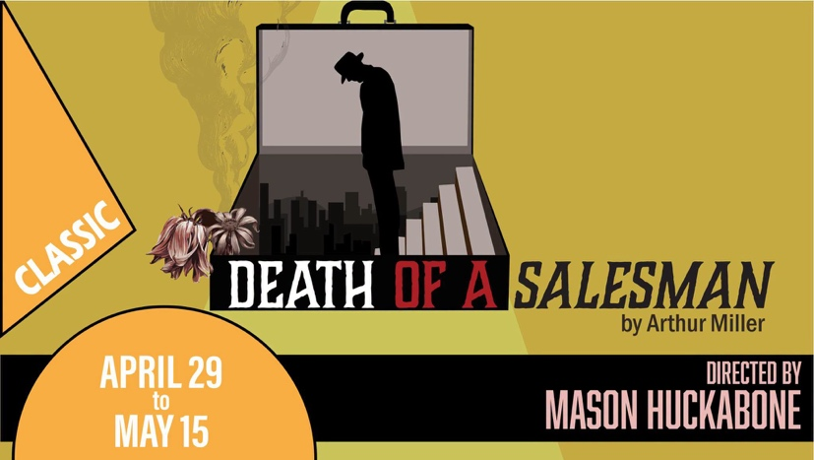

Audition Dates: Sunday, November 29th 2:00pm – 8:00pm
Tuesday, December 1st 5:00pm – 10:00pm
Audition and Show Location: Grande Prairie Live Theatre 10130 98 Avenue, Grande Prairie, AB
Synopsis:
Traveling salesman Willy Loman cannot understand how he failed to win success and happiness. Several tragic soul-searching revelations – concerning his wife, his sons and his business associates – underscore how his quest for the “American Dream” kept him blind to the people who truly loved him. Arthur Miller’s thrilling play – a work of deep and revealing beauty – remains one of the most profound achievements in the American theatre.
Rehearsal Schedule:
Rehearsals are tentatively scheduled for Monday and Wednesday evenings from 6:00 – 9:00 pm, and Saturday mornings from 10:00 – 1:00 pm, beginning Saturday, February 20, 2027.
Performance Dates:
Performances are scheduled for Thursday, Friday, and Saturday evenings at 7:30 pm, opening Thursday, April 29, 2027, and closing Saturday, May 15, 2027. The call time for these performances is 6:00 pm.
Special Matinee Performance:
By auditioning for the production, the performer agrees that, subject to ticket availability, the Director may, at their discretion, add a 2:00 pm matinee performance on any of the three (3) performance Saturdays. The call time for these performances would be 12:30 pm. While leaving the theatre between the shows would not be permitted, dinner would be provided by the theatre.
How to Prepare:
- We kindly request that you read the attached rehearsal schedule, and ensure your calendar is suitable for these dates before proceeding with the audition.
- To book a fifteen (15) minute audition slot and receive more information, please contact the GPLT Box Office at (780) 538-1616 or admin@gplt.ca.
- There are roles available for seven (7) men and four (4) women.
- Please read the script and familiarize yourself with the plot. Perusal scripts are available from the GPLT Box Office for a $5 refundable deposit.
- Please prepare a one to three (1–3) minute monologue of your choice. You are not expected to be memorized.
- Please review the scene assigned to the character you're auditioning for and be prepared to read it during your audition. Somebody will read the other part(s) for you. You are not expected to be memorized, and scripts will be available at the audition.

If you are interested in joining the production team, please contact the GPLT Box Office at (780) 538-1616 or admin@gplt.ca with your contact information and we will be in touch! We are actively searching for members in all areas of the production team!

Content Warnings:
- Mature content (including infidelity, marital tension, mental health struggles, disillusionment, and suicide)
- ﻿﻿Verbal aggression and emotional conflict
- ﻿﻿Coarse language
- ﻿﻿Theatrical effects (including theatrical haze, flashing lights)
- ﻿﻿Onstage smoking and alcohol consumption

Equity, Diversity, & Inclusion:
The Grande Prairie Live Theatre encourages auditions from artists who self-identify as members of under-represented communities to ensure that the stories we tell, as well as the composition of our artists, board, staff, students, and audience are reflective of the diverse lived experiences in this dynamic city.
Land Acknowledgement:
The Grande Prairie Live Theatre respectfully acknowledges the Beaver, Cree, Dene, and Métis people as the original caretakers of these Lands and surrounding areas. We are grateful to live, learn, work and perform on Treaty 8 territory within Turtle Island and acknowledge these Lands have been home to diverse and sovereign First Nations and Inuit Nations since Time Immemorial.
If you have any questions or concerns, or require an alternative audition date or time, please contact the Director at (780) 814-2120 or huckabonemason@gmail.com.

CHARACTERS
The pronouns and ages listed are the playwriter’s descriptions of the characters. Actors are welcome to express interest in any roles, regardless of gender or age.
WILLY LOMAN – 50-60. He/Him. Any Ethnicity.
The Salesman. Willy believes wholeheartedly in the American Dream of easy success and wealth, but he has never achieved it.
Audition Sides: Pg. 60-61
LINDA – 50-60. She/Her. Any Ethnicity.
Loyal and loving wife of Willy. Occasionally, she seems to be taken in by Willy’s hopes for future glory and success, but at other times, she seems far more realistic and less fragile than her husband.
Audition Sides: Pg. 40
BIFF – 34. He/Him. Any Ethnicity.
Willy and Linda’s elder son. Biff led a charmed life in high school as a football star with scholarship prospects and many friends and admirers. He failed math, however, and did not have enough credits to graduate. He is grasping for answers in life, having worked as a farm laborer for years and still unable to meet his father’s standards of success. Over the course of the play, he has the revelation that he, like his father, is not destined for greatness.
Audition Sides: Pg. 105
HAPPY – 32. He/Him. Any Ethnicity.
Willy and Linda’s younger son. Happy has lived in Biff’s shadow all of his life, but he compensates by nurturing his relentless sex drive and professional ambition. Although he works as an assistant to an assistant buyer in a department store, Happy presents himself as supremely important.
Audition Sides: Pg. 78-80
BERNARD – Early 30s. He/Him. Any Ethnicity.
Charley's son. Although Willy used to mock Bernard for studying hard, Bernard always loved Willy’s sons dearly and regarded Biff as a hero. Bernard provided Biff with answers while they were in high school and attempted to help Biff study so that he would graduate. He is now a successful lawyer.
Audition Sides: Pg. 72
THE WOMAN – 40-55. She/Her. Any Ethnicity.
Willy’s mistress when Happy and Biff were in high school. A secretary Willy met on his sales route.
Audition Sides: Pg. 91-92
CHARLEY – 50+. He/Him. Any Ethnicity.
The Loman’s next-door neighbor. Charley owns a successful business and his son, Bernard, is a wealthy, important lawyer. Charley gives Willy money to pay his bills, and Willy reveals at one point that Charley is his only friend.
Audition Sides: Pg. 75
UNCLE BEN – 60+. He/Him. Any Ethnicity.
Willy’s wealthy older brother. He made a fortune in Africa by the time he was 21 years old. Ben has recently died and appears only in Willy’s “daydreams.” Willy regards Ben as a symbol of the success that he so desperately craves for himself and his sons.
Audition Sides: Pg. 33-34
HOWARD WAGNER – 30-40. He/Him. Any Ethnicity.
Willy’s boss. Howard inherited the company from his father. Though much younger than Willy, Howard treats Willy with condescension and eventually fires him, despite Willy’s wounded assertions that he named Howard at his birth.
Audition Sides: Pg. 63
JENNY – 20-30. She/Her. Any Ethnicity.
Charley’s secretary.
Audition Sides: Pg. 69
STANLEY – 20-30. He/Him. Any Ethnicity.
A waiter in a restaurant and a friend of Happy’s.
Audition Sides: Pg. 76-77
MISS FORSYTHE – 20-30. She/Her. Any Ethnicity.
A young lady Happy picks up in a bar.
Audition Sides: Pg. 78-79
LETTA – 20-30. She/Her. Any Ethnicity.
Friend to Miss Forsythe. A young woman that Happy and Biff meet at Frank’s Chop House.
Audition Sides: Pg. 89

